Local Government pension Scheme
Mandatory Employer Discretions Policy Statements
Admitted Bodies / Academies
Introduction
The Local Government Pension Scheme (LGPS) in England and Wales was amended from April 2014 so that benefits for service after 31 March 2014, build-up on a defined benefit career average revalued earnings (CARE) basis, rather than on a defined benefit final salary basis.

The provisions of the CARE scheme, together with the protections for members’ pre 1 April 2014 final salary rights, are contained in the Local Government Pension Scheme Regulations 2013 [SI 2013/2356] and the Local Government Pension Scheme (Transitional Provisions, Savings and Amendment) Regulations 2014 [SI 2014/525].

Scheme employers participating in the LGPS in England or Wales must formulate, publish and keep under review a statement of policy on all mandatory discretions (or where the discretion is non-mandatory, are recommended to) which they have the power to exercise in relation to members of the CARE Scheme and earlier schemes.

Overall, Scheme employers participating in the LGPS in England or Wales:

1) Must formulate, publish and keep under review a statement of policy on all mandatory discretions (or where the discretion is non-mandatory, are recommended to) in accordance with:
- regulation 60 of the LGPS Regulations 2013 [SI 2013/2356],
- paragraph 2(2) of Schedule 2 to the LGPS (Transitional Provisions, Savings and Amendment) Regulations 2014 [SI 2015/525],
- regulation 66 of the Local Government Pension Scheme (Administration) Regulations 2008 (in respect of leavers between 1 April 2008 and 31 March 2014) [SI 2008/239],
- regulation 106 of the Local Government Pension Scheme Regulations 1997 (in respect of leavers between 1 April 1998 and 31 March 2008) [SI 1997/1612], and
- by virtue of regulation 4 of the LGPS (Transitional Provisions) Regulations 1997 [SI 1997/1613], regulation 106 of the Local Government Pension Scheme Regulations 1997 [SI 1997/1612] (in respect of leavers prior to 1 April 1998) [SI 1997/1612].

2) Must (other than admission bodies1) formulate, publish and keep under review a statement of policy on all mandatory discretions in accordance with regulation 7 of the Local Government (Early Termination of Employment) (Discretionary Compensation) (England and Wales) Regulations 2006 [SI 2006/2914], operative from 1 October 2006.

3) Must (other than admission bodies2) formulate, publish and keep under review a statement of policy on all mandatory discretions (or where the discretion is non-mandatory, are recommended to) in accordance with regulation 26 of the Local Government (Early Termination of Employment) (Discretionary Compensation) (England and Wales) Regulations 2000 [SI 2000/1410] (operative from 1 October 2000 up to and including 30 September 2006).

4) Must (other than admission bodies) formulate, publish and keep under review a statement of policy on all discretions relating to injury allowances in accordance with regulation 14 of the Local Government (Discretionary Payments) (Injury Allowances) Regulations 2011 [SI 2011/2954].

5) Are recommended to formulate, publish and keep under review a Statement of Policy on the non-mandatory discretions under the Local Government (Discretionary Payments) Regulations 1996 [SI 1996/1680] which relate to: injury allowances in respect of leavers, deaths and reduction in pay that occurred before 16 January 2012; and which relate to gratuities in respect of leavers and deaths that occurred before 16 January 2012.

If the Scheme employer decides to amend the policy, they must send a copy to the relevant administering authority within one month of the date of the decision to amend the policy.

In formulating and reviewing its policy a Scheme employer is required by the regulations to have regard to the extent to which the exercise of their discretionary powers could lead to a serious loss of confidence in the public service.

A Scheme employer should always ensure that their discretionary policies are kept up to date.

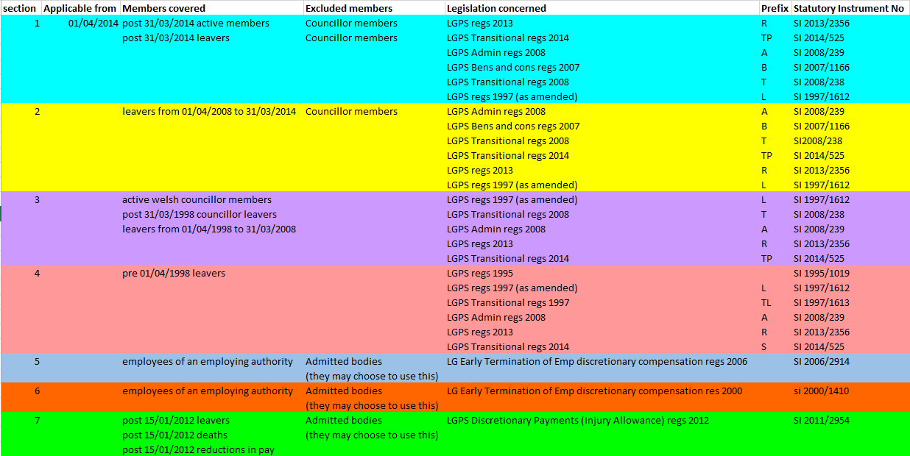

Admitted Body / Academy Employers
Sections 1, 2, 3, and 4 are mandatory
Sections 5, 6, and 7 are optional

