This paper is addressed to Croydon Council, in its capacity as Administering Authority of the London Borough of Croydon Pension Fund (“the Fund”). It has been prepared for the purpose of providing a summary of the consultation on the Fund’s draft Funding Strategy Statement (“the FSS”) which forms part of the stakeholder engagement at the 2025 triennial funding valuation (”the valuation”).
This paper has not been prepared for use for any other purpose and should not be so used. The paper should not be disclosed to any third party except as required by law or regulatory obligation or with our prior written consent. We accept no liability where the paper is used by or disclosed to a third party unless we have expressly accepted such liability in writing. Where this is permitted, the paper may only be released or otherwise disclosed in a complete form which fully discloses our advice and the basis on which it is given.

Funding Strategy Statement (FSS)
Under LGPS Regulations, all funds have a statutory obligation to produce an FSS. It is a key document for the Fund, in two ways:
- The inputs it requires: the Fund’s officers and Pensions Committee need to go through a process to be satisfied that the Fund is managing funding risks and will be collecting an appropriate level of contributions from all employers in the Fund. The FSS provides a helpful framework for organising this process and covering all the necessary areas.


- The outputs it gives: the finalised FSS itself should be a clear and transparent reference point for the Fund’s stakeholders, to set out how the Fund manages funding risks and provide proof that the contribution arrangements are solidly derived, fair and consistent. It will also help in any future discussions with employers, perhaps where an approach is queried or questions are raised.

Draft Funding Strategy Statement Consultation Summary

The FSS is prepared in collaboration with the Fund Actuary and forms an integral part of the framework within which to carry out the triennial valuation to set employer contributions. The FSS also outlines how the funding strategy fits in with the investment strategy.
The current FSS was approved by the Pensions Committee in December 2023 and is published on the Fund’s website here.

2025 FSS review
In January 2025, updated guidance for preparing and maintain a FSS was published by the Ministry of Housing,
Communities and Local Government (“MHCLG”), the Scheme Advisory Board’s (“SAB”s’) Compliance and Reporting Committee and the Chartered Institute of Public Finance and Accountancy (“CIPFA”). The updated guidance replaces 2016 guidance produced by CIPFA.
The FSS and policy documents at the 2022 valuation were broadly in line with the new FSS guidance requirements and therefore no fundamental changes have been made to the structure or content of the FSS as part of this review for the 2025 valuation. However, a full review of the Fund’s FSS has been carried out, with minor changes made to ensure the document is fully compliant with the updated FSS guidance and key principles document.

February 2026 001 The Pension Committee approved a draft of the revised FSS and related policies at their meeting in September.
However, as a reminder, a summary of the most significant changes include:

1. Review of funding assumptions
The Fund Actuary has reviewed the funding assumptions as part of the 2025 valuation. These have been updated to reflect emerging experience and market conditions as at 31 March 2025. All assumptions are ‘best estimate’ except for the discount rate assumption which includes a margin of prudence required by the LGPS Regulations.
The Fund Actuary models 5,000 simulations of possible future economic outcomes to set robust funding plans at whole fund level and for each individual employer. At the 2025 valuation, the Fund has adopted a prudence level of 80% (previously 75% at the 2022 valuation) for ‘ongoing’ funding to reflect the increased uncertainty and volatility in markets, and this change was agreed by Pensions Committee in September 2025. This means that the Fund assumes a level of investment return (discount rate) that is achieved in 80% of the simulations of the future. The Fund believes this strikes an appropriate balance between managing longer-term risk and shorter-term affordability for employers in the current environment.

2. Review of contribution rate calculations
Section 2 of the draft FSS sets out the approach to setting employer contribution rates. The approach is largely unchanged from 2022, with the following exception:
- Minimum likelihood of success (in Table 2) - updated to 80% to align with the agreed prudence level at 2025.

3. Review of additional policy documents
To help employers navigate the FSS, the Fund has set out specific policies in the following areas (and these are included on the Fund’s website):
- Academies policy
- Admission Policy
- Bulk transfer policy
- Cessation policy
- Contribution reviews policy
- Prepayments policy
Each policy document has been reviewed at 2025 to reflect the new guidance and any technical or regulatory changes; however the content of each policy remains largely unchanged from 2023.
Employers were encouraged to read any of the additional policies that may impact their participation in the Fund (eg academies and MATs should read the academies policy).

2025 FSS consultation
The draft FSS and policies were agreed by Pension Committee in September 2025 and put out for consultation from 8 January 2026. The consultation went out to all Fund employers and wider stakeholders such as the Department for Education (“DfE)”.
The recently updated FSS guidance sets out best practice principles that funds should follow and encourages funds to consider the effectiveness of the of the FSS consultation. To help meet these expectations but also
002
recognise the busyness of employers, the Fund has actively sought out engagement from all stakeholders using an employer engagement portal hosted by the Fund Actuary. Employers have been encouraged to provide feedback on the consultation process, the FSS accessibility, and to provide any further questions or comments on the content within the draft FSS.
From the responses received via the engagement portal, most employers found the FSS to be helpful and that they were provided with sufficient detail and time to prepare a response (see appendix for a summary of responses to this accessibility survey). The Fund has engaged with employers (and other stakeholders) where specific comments (and questions) on the content of the Fund’s FSS have been raised (see appendix for a summary of these questions and the Fund’s responses).

Next steps
The FSS consultation period closed on 27 February 2026.
All comments received during the consultation are considered by Fund Officers, within input from the Fund actuary where required, before preparing the final 2025 valuation FSS for sign off (which will then take effect from 1 April 2026). The final FSS provides the framework (until the next review date), for all employers participating in the Fund including new employers joining and employers exiting the Fund over this period.
The Pension Committee will be asked to approve the final version of the FSS at its March 2026 meeting.
The next full review of the FSS is due to take place as part of the 2028 formal funding valuation, however ad-hoc revisions to the FSS and policies are possible, with any material changes needing formal approval by Pension Committee.

For and on behalf of Hymans Robertson LLP

003

Appendix 1 – Survey on the FSS accessibility and consultation process
The Fund shared the draft FSS with all employers and requested that they all access an Employer Engagement Portal (hosted by the Fund Actuary) to share their views on the FSS, ensuring the fund has facilitated and can document an effective FSS consultation.
At the time of writing, 18% of the employers who were issued employer results (and invited to respond to the consultation) have responded via the Portal. This is a significant increase in employer engagement from previous valuations.
Employers were surveyed on the accessibility of the FSS document and the consultation process to ensure this has been effective (or otherwise). A summary of these responses is below:
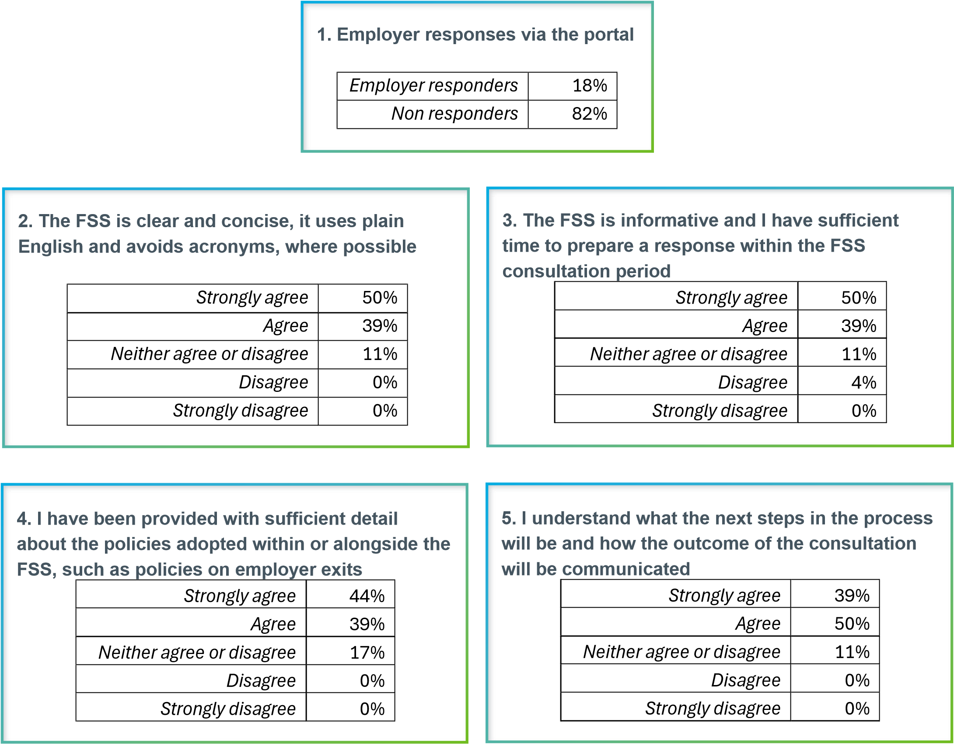

004

Appendix 2 – Employer questions and comments on the FSS
Within the Employer Engagement Portal, employers were asked to provide any specific questions or comments on the draft FSS. From the employers who responded, the majority provided positive comments – noting that the information has been helpful and that employers are satisfied with the process and the outcomes.
Where employers provided questions or challenges, these broadly fell into the following categories:
- Contribution strategy, including modelling approach & parameters: how the fund has calculated employer contribution rates.
- Surplus management: how the fund is managing employer surpluses via contribution rates (and policies).
- Policies: questions on specific funding policies, either contained within the core FSS document or the additional policy documents.
- Other funding factors: other questions or comments on valuation outcomes, not specifically related to aspects of the FSS.
A summary of the questions / comments that have been raised by stakeholders across the LGPS in general are set out below, alongside the Fund’s general view in response.

Contribution strategy, including modelling approach & parameters

Primary rate calculation
Question / comment: Primary rates are overstated and the approach is not transparent.
Response: The Primary contribution rate has been calculated based on the approach and parameters set out in Section 2, and the assumptions set out in appendix E. This information aims to provide employers with transparency of the approach and assumptions (although we appreciate that there is a level of complexity inherent in any actuarial model or funding strategy given the long-term open nature of the LGPS).
We do not believe that the Primary Rates are overstated – instead, they reflect the estimated cost of future accrual based on the Fund’s funding strategy (ie the agreed approach, assumptions and the level of prudence).

Modelling approach
Question / comment: the modelling approach is not transparent and is leading to overly cautious / high contribution rates.
Response: As set out in the first paragraph above, the assumptions used to calculate the contribution rates are set out in appendix E of the FSS. The actuary uses a risk-based (stochastic) model which projects the employer’s expected benefits payments over the next 20 years under 5,000 different simulations. Further detail on the modelling approach is available in Hymans Robertson’s LGPS Valuations Toolkit 2025.
The Fund strongly favours a stochastic approach to setting contribution rates as we feel this is a truer reflection of the risks over a future funding period, particularly given long-term open nature of the LGPS.
Contribution setting factors - Minimum likelihood of success (‘prudence’)
Question / comment: The fund is being too prudent / has increased prudence. What is the rationale? The ongoing basis is now as prudent as a basis typically used for exiting employers.
Response: Regulations set out a requirement for the Fund to set prudent assumptions for valuing pension benefits to support the aims of solvency, stability and to ultimately protect member benefits. ‘Prudence’ is not clearly defined
005
anywhere in the Regulations or supporting guidance, however it is generally accepted that funds should aim to strike a balance of not being too prudent or imprudent. This typically leads to prudence levels falling somewhere between 70% and 85% across the LGPS. The level of prudence adopted at any point in time reflects several factors, including each fund’s risk appetite and the prevailing funding and economic environment.
Based on these factors, the Fund has taken the view to use a prudence of 80% at the 2025 valuation.
Also note, exit valuations are typically carried out using assumptions that have an equivalent 85%-90% prudence level attached, meaning the Fund’s ongoing funding basis is lower.
The level of prudence has been approved by the pension committee as part of the over-arching governance of the valuation process and will remain under review at future valuations. In the future, given different economic or funding conditions, it may be appropriate to reduce prudence to continue to support the Fund’s aims of affordable, stable contributions for employers.

Contribution setting factors - time horizon
Question / comment: the time horizon should be reduced by 3 years from the previous valuation, which would result in quicker surplus return.
Response: The time horizon is set to reflect an employer’s participation, eg a long-term, ongoing participant can have a longer-term funding plan to aid stability, and therefore we do not intend to change the time horizon whether an employer is in deficit or in surplus.

Surplus management

Contributions - surplus return
Question / comment: Contributions are not reducing quickly enough / do not reflect the strong funding position.
Response: The Fund has set total contribution rates in line with the principles set out above. The actuary has modelled contribution rates that have at least an 80% chance of being fully funded in 20 years’ time. This approach considers the evolution of each employer’s funding position and cashflows over the full 20 years - as opposed taking a point estimate of the funding position on one day (31 March 2025) and returning that notional ‘surplus’ over a given number of years. This risk-based approach allows for future funding risks by considering a number of possible future evolutions of each employer’s funding position and aligns with the principles set out in the Fund’s FSS.

Recovery / surplus return periods
Question / comment: the implied surplus return periods are too long and not consistent with the time horizons used when employers were in deficit.
Time horizon for deficit recovery is clear, but it is unclear how quickly surplus is being returned. Application of a contribution floor and/or higher funding target means that surplus return period is longer than the stated time horizon.
Response: The Fund’s approach to setting contribution rates is detailed in the Fund FSS’s (and set out under ‘modelling approach’ above). The actuary has modelled an approach that aims for at least 100% funding in 20 years’ time, not whether the employer is in surplus or deficit at a single snapshot in time (the valuation date, or time 0). This future time period reflects the ongoing, long-term nature of the employer.
Calculations that imply a longer surplus return period are more often based on a very simplistic approach that doesn’t appropriately capture the future funding risks and the evolution of the funding position over the next 20 years and is not aligned to our FSS and the funding approach used by the Fund.
006

Contributions - stabilisation
Question / comment: Stabilisation of contribution rates is leading to overfunding and not returning surplus quickly enough.
Response: The use of stabilisation parameters for employers (which limits increases/decreases in contribution rates to ±1% of pay pa) is based on our aim to reduce contribution volatility and support long-term planning for employers. This approach is consistent with the Fund’s broader funding strategy and risk management objectives, and this policy has been supported by employers throughout multiple valuations.

Policies

Early retirement strains
Question / comment: Employers should be allowed to offset the current strong funding position against any future early retirement strain costs (which are currently required to paid in full when they occur, regales of the current funding position).
Response: The Fund will not consider offsetting early retirement strains against the funding position as this is an employer choice and such an action could create moral hazard.
However, where there is an early retirement strain on ill health grounds, the Fund may consider whether this can be offset against any funding surplus in certain circumstances.

Contribution rate reviews
Question / comment: The contribution review policy does not offer enough flexibility to appropriately deal with employer surpluses.
Response: The Fund’s policy on inter-valuation reviews has been written to reflect the Regulations and associated SAB guidance on employer flexibilities. The content of this policy is standard, and no further restrictions have been added following review at the 2025 valuation.

Asset allocation for converting academies
Question / comment: initial funding levels of academies upon conversion are capped at 100% (even when the local authority is in significant surplus). The academy has contributed towards this surplus (as an LEA school) and should benefit in full. In the past, when local authorities were in deficit, academies took on a share of this deficit on conversion.
Response: On conversion from LEA status, assets of no more than the fully funded (100%) value of the transferring liabilities are transferred to the Academy/MAT. When the local authority is in surplus, this ensures that any surplus in respect of the transferring liabilities is retained by the local authority. This is appropriate because the local authority is responsible for meeting the deferred and pensioners obligations of former staff of the transferring school. This provides protection to the local authority from adverse market conditions that may arise and worsen the funding position (specifically, in respect of the legacy deferred and pensioner obligations).
This is a common approach applied across the LGPS, and it is in line with principles that generally apply when determining asset shares in other situations (eg bulk transfers of membership in or out of the scheme or between LGPS funds).
If it was possible to identify the deferred and pensioners obligations of each converting LEA school, we could allow for the transfer of these liabilities to the Academy/MAT, and any surplus could also transfer (as the local authority wouldn’t be on risk for any shortfall emerging in respect of these legacy liabilities). However, it is not practical (or possible in most cases) to identify the legacy deferred and pensioner obligations of each LEA school –we would not be confident that the required data would be available.
007

London Borough of Croydon Pension Fund | Hymans Robertson LLP

Other funding factors

Post valuation experience
Question / comment: the funding position of employers has likely improved significantly since the valuation date due to market movements, and this should be reflected in the contribution rates.
Response: Where there is a significant event after the valuation, it is possible to take this into consideration when setting contribution rates. The Fund has experienced strong investment performance since 31 March 2025; however, we consider this to be simply a consequence of general market movements over that time. In our view, general market performance and fluctuations is not an appropriate factor to consider as ‘post valuation experience’. This is also true had investment performance been poor over this period. The impact of this experience (if it holds in the future) will be reflected in the funding positions (and future contribution rate considerations) as part of the 2028 valuation.

Contributions being paid in 2025/26
Question / comment: Employer contributions being paid in 2025/26 are higher than now required and employers should benefit from this overpayment with a reduction / offset to their new contribution rates.
Response: Contribution rates are set every 3 years at the formal valuation (on 31 March) and take effect from 1 April the following year. Given the time that the valuation takes to complete, there is a necessary 1-year lag in the contribution rates. Employer rates that are paid during the valuation year represent the final year of the rates certified at the previous valuation and therefore no adjustment takes place.
This approach would be the same had contribution rates been increasing or decreasing at the 2025 valuation and is therefore fair to all employers. The impact of these contributions (paid during 2025/26) will be reflected in the funding positions (and future contribution rate considerations) as part of the 2028 valuation.

Peer comparison of employer contribution rates
Question / comment: Contribution rates being paid by similar employers in this fund or in other funds are lower.
Other similar employers have received greater reductions in contribution rates.
Response: Peer comparison with other employers in the Fund, or indeed across other LGPS funds, should be avoided. Comparing contribution outcomes can be misleading and does not mean that any employers are paying ‘too much’ or indeed ‘too little’ relative to another. The funding strategy (and contribution rate) for each employer in the Fund reflects its own unique circumstances - including the funding position, demographic profile and employer covenant. Similarly, contribution outcomes across different LGPS funds will vary, reflecting various funding and investment strategy decisions, local circumstances, and risk appetite.
Each employer is responsible for funding the benefits of their own employees (past and future), so employers paying more now are likely to pay less in the future, and vice versa (all else being equal)
London | Birmingham | Glasgow | Edinburgh T 020 7082 6000 | www.hymans.co.uk
Hymans Robertson LLP is a limited liability partnership registered in England and Wales with registered number OC310282. Authorised and regulated by the Financial Conduct Authority and licensed by the Institute and Faculty of Actuaries for a range of investment business activities.

© Hymans Robertson LLP 2026. All rights reserved.

